Industrial Internship Report on
”Forecasting of Smart City Traffic Patterns”
Prepared by
MADDEBOINA DEEKSHITA

Executive Summary
This report presents the work completed during the Industrial Internship conducted by Upskill Campus in collaboration with UniConverge Technologies Pvt. Ltd. The project, titled Forecasting of Smart City Traffic patterns, focuses on analyzing traffic data to predict traffic flow and identify congestion patterns using Python. The dataset was cleaned, processed, and analyzed using Pandas, while Matplotlib was used to visualize traffic trends through various graphs and charts. The project helps identify peak traffic hours, traffic variations on weekdays and holidays, and provides valuable insights for better traffic management in smart cities. This internship improved my technical knowledge in Python, data analysis, data visualization, and machine learning concepts while giving me practical exposure to solving real-world traffic forecasting problems.

TABLE OF CONTENTS
1 Preface 3
2 Introduction 4
2.1 About UniConverge Technologies Pvt Ltd 4-8
2.2 About upskill Campus 8-9
2.3 Objective 10
2.4 Reference 10
2.5 Glossary 10
3 Problem Statement 11
4 Existing and Proposed solution 11
5 Proposed Design/ Model 12
5.1 High Level Diagram (if applicable) 12
5.2 Low Level Diagram (if applicable) 13
5.3 Interfaces (if applicable)……………………………………………………………………………………………………….14-15
6 Performance Outcome…………………………………………………………………………………………………………………..16
6.1 Test Plan/ Test Cases………………………………………………………………………………………………………………….16
6.2 Test Procedure ………………………………………………………………………………………………………………………….16
6.3 Performance Outcome……………………………………………………………………………………………………………… 17
7 My Learnings………………………………………………………………………………………………………………………………….. 17
8 Future scope…………………………………………………………………………………………………………………………………….17

Preface

The six-week industrial internship provided me with an opportunity to gain practical knowledge in Machine Learning, Data Analysis, and Traffic Prediction. During this internship, I worked on the project Forecasting of Smart City Traffic Patterns, where I learned how to collect, clean, preprocess, analyze, and visualize traffic data using Python. I also gained hands-on experience with Python libraries such as Pandas, NumPy, Matplotlib, and Scikit-learn for data analysis and predictive modeling.

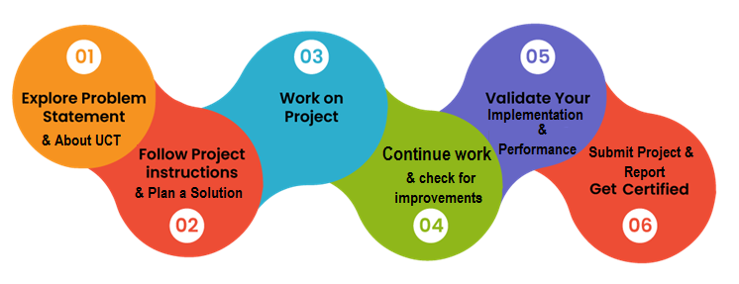
The internship enhanced my problem-solving ability, analytical thinking, and programming skills. It also improved my understanding of data preprocessing, feature engineering, traffic pattern analysis, data visualization techniques, and machine learning model development for forecasting traffic flow in smart cities.
I sincerely thank Upskill Campus, UniConverge Technologies Pvt. Ltd., my college faculty, and everyone who supported and guided me throughout this internship. This experience has strengthened my confidence, improved my technical skills, and motivated me to continue learning advanced concepts in Data Science and Machine Learning for solving real-world problems.

Introduction

About UniConverge Technologies Pvt Ltd
A company established in 2013 and working in Digital Transformation domain and providing Industrial solutions with prime focus on sustainability and RoI.
For developing its products and solutions it is leveraging various Cutting Edge Technologies e.g. Internet of Things (IoT), Cyber Security, Cloud computing (AWS, Azure), Machine Learning, Communication Technologies (4G/5G/LoRaWAN), Java Full Stack, Python, Front end etc.

- UCT IoT Platform()
UCT Insight is an IOT platform designed for quick deployment of IOT applications on the same time providing valuable “insight” for your process/business. It has been built in Java for backend and ReactJS for Front end. It has support for MySQL and various NoSql Databases.
It enables device connectivity via industry standard IoT protocols - MQTT, CoAP, HTTP, Modbus TCP, OPC UA
- It supports both cloud and on-premises deployments.
It has features to
• Build Your own dashboard
• Analytics and Reporting
• Alert and Notification
• Integration with third party application(Power BI, SAP, ERP)
• Rule Engine

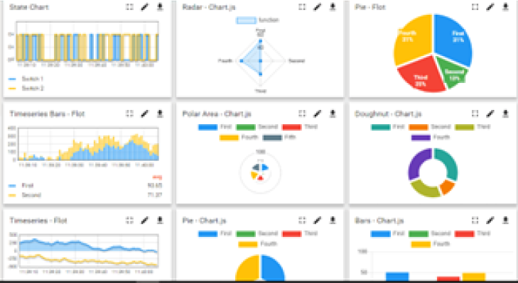
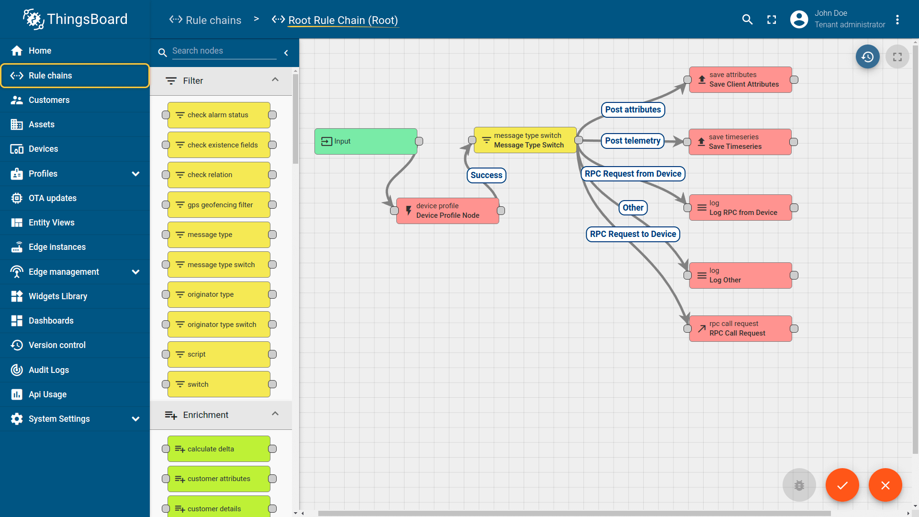

- Smart Factory Platform ()
Factory watch is a platform for smart factory needs.
It provides Users/ Factory
- with a scalable solution for their Production and asset monitoring
- OEE and predictive maintenance solution scaling up to digital twin for your assets.
- to unleased the true potential of the data that their machines are generating and helps to identify the KPIs and also improve them.
- A modular architecture that allows users to choose the service that they what to start and then can scale to more complex solutions as per their demands.
Its unique SaaS model helps users to save time, cost and money.
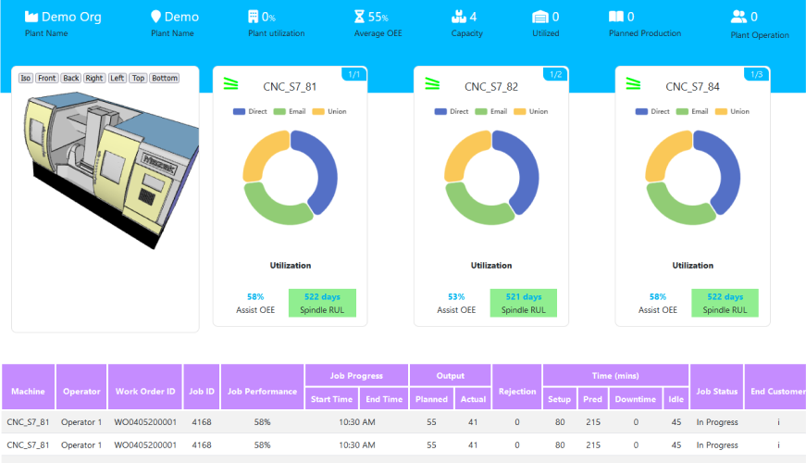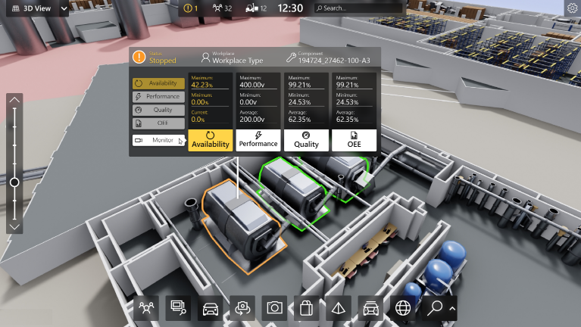

- 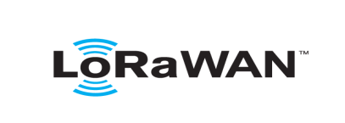based Solution
UCT is one of the early adopters of LoRAWAN teschnology and providing solution in Agritech, Smart cities, Industrial Monitoring, Smart Street Light, Smart Water/ Gas/ Electricity metering solutions etc.
- Predictive Maintenance
UCT isproviding Industrial Machine health monitoring and Predictive maintenance solution leveraging Embedded system, Industrial IoT and Machine Learning Technologies by finding Remaining useful life time of various Machines used in production process.
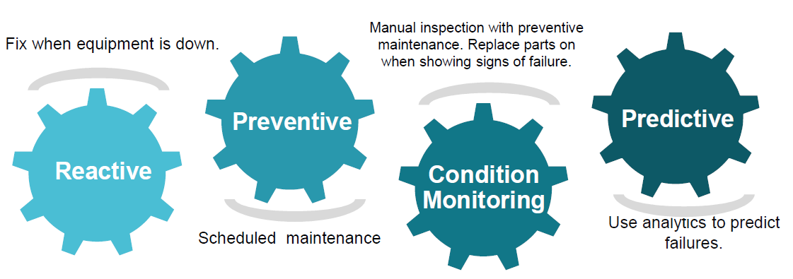

About upskill Campus (USC)
upskill Campus along with The IoT Academy and in association with Uniconverge technologies has facilitated the smooth execution of the complete internship process.
USC is a career development platform that delivers personalized executive coaching in a more affordable, scalable and measurable way.




Seeing need of upskilling in self paced manner along-with additional support services e.g. Internship, projects, interaction with Industry experts, Career growth Services
https://www.upskillcampus.com/
upSkill Campus aiming to upskill 1 million learners in next 5 year

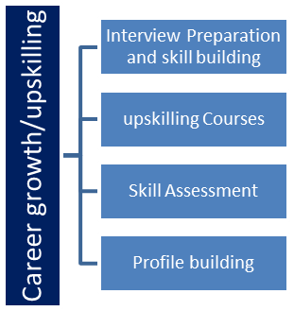
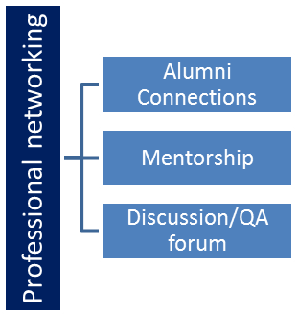
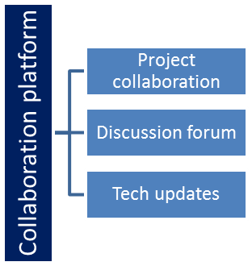
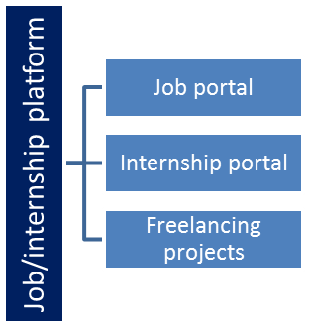

The IoT Academy
The IoT academy is EdTech Division of UCT that is running long executive certification programs in collaboration with EICT Academy, IITK, IITR and IITG in multiple domains.

Objectives of this Internship program
The objective for this internship program was to
☛To analyze smart city traffic data and understand traffic flow patterns.
☛To clean and preprocess the traffic dataset for accurate analysis.
☛To visualize traffic trends and congestion using graphs and charts.
☛To develop a machine learning model for forecasting traffic patterns.
☛To improve Python programming, data analysis, and data visualization skills.

2.4 Reference
[1] Python Software Foundation. Python Documentation. https://docs.python.org⁠
[2] Pandas Development Team. Pandas Documentation. https://pandas.pydata.org⁠
[3] NumPy Developers. NumPy Documentation. https://numpy.org⁠

Glossary
Terms | Acronym
ML | Machine Learning
csv | Comma Separated
Dataset | Collection Separated Values
Pandas | Python library used for data analysis
Traffic Forecasting | Predicting future traffic flow using historical data

Problem Statement

Traffic data is generated continuously in smart cities, but identifying traffic patterns and predicting future traffic flow from raw data is challenging. Traffic authorities and city planners require meaningful insights to manage congestion, improve road safety, and optimize transportation systems.
The objective of this project is to analyze smart city traffic data, clean and preprocess the dataset, perform exploratory data analysis, and forecast traffic patterns using Python. The generated graphs and analysis help identify peak traffic hours, traffic trends across different days, and provide valuable insights for efficient traffic management and smart city planning.

Existing and Proposed solution

Most traffic datasets are available only as raw tables, making it difficult to identify traffic patterns and congestion trends quickly. Manual analysis consumes time and may lead to inaccurate conclusions.
The proposed solution uses Python with Pandas, NumPy, and Matplotlib to preprocess the data, remove missing values, analyze traffic flow, and generate meaningful visualizations such as bar charts and line graphs. A machine learning model is used to forecast traffic patterns and identify peak traffic hours. This approach provides a simple and efficient way to understand traffic behavior and supports better traffic management in smart cities.

Code submission (Github link)
https://github.com/deekshitamaddeboina96-commits/Upskill-campus-/blob/main/Forecasting_of_smart_city_traffic_patterns.ipynb

Report submission (Github link) : first make placeholder, copy the link.

https://github.com/deekshitamaddeboina96-commits/Upskill-campus-/blob/main/Forecasting%20Of%20Smart%20city%20traffic%20patterns_Deekshita_USC_USY.docx

Proposed Design/ Model

The proposed system is designed to analyze and forecast smart city traffic patterns using Python. The dataset is first imported into Google Colab, where preprocessing techniques are applied to clean the data and remove missing values. After preprocessing, the data is analyzed using the Pandas library to identify traffic patterns, peak traffic hours, and traffic flow trends across different days and locations.
The processed data is then visualized using Matplotlib through bar charts and line graphs, making it easier to compare traffic trends and understand congestion patterns. Finally, a machine learning model is used to forecast future traffic patterns, and the results are interpreted to provide meaningful insights for efficient traffic management and smart city planning.

High Level Diagram (if applicable)
Traffic Dataset
Data Collection

Data preprocessing
Traffic Data Analysis

Data visualization
Traffic Prediction & Result

Figure 1: HIGH LEVEL DIAGRAM OF THE SYSTEM

Low Level Diagram (if applicable)

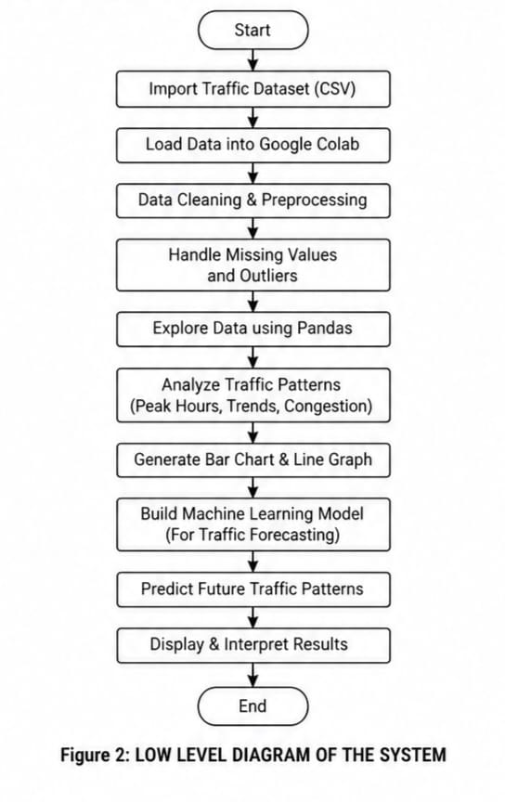

Interfaces (if applicable)
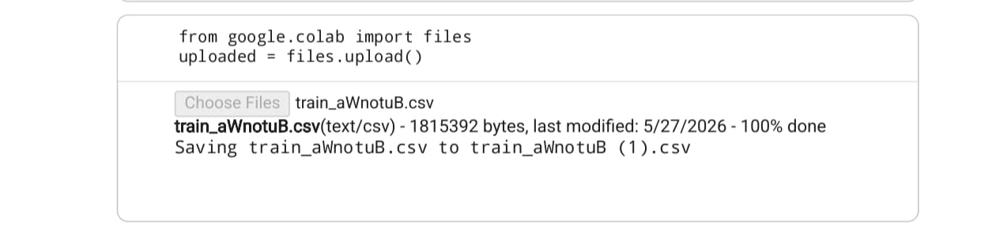
The traffic dataset is uploaded into Google Colab using the files.upload() function. This allows the user to select the traffic dataset file from the local system and load it into the notebook environment for preprocessing, analysis, visualization, and traffic pattern forecasting.
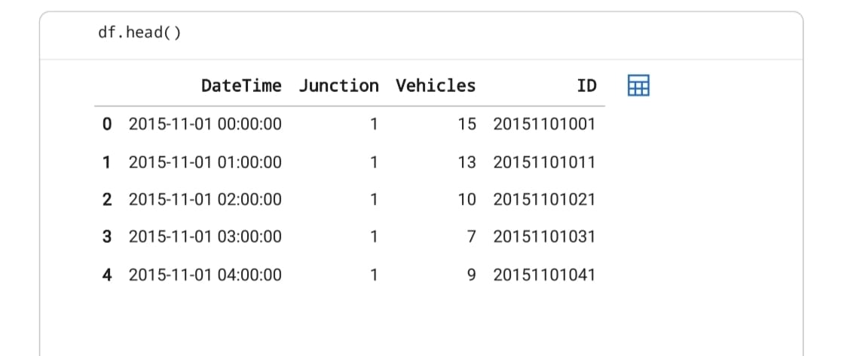

Dataset preview displaying the first few records of the smart city traffic dataset used for traffic pattern analysis and forecasting.
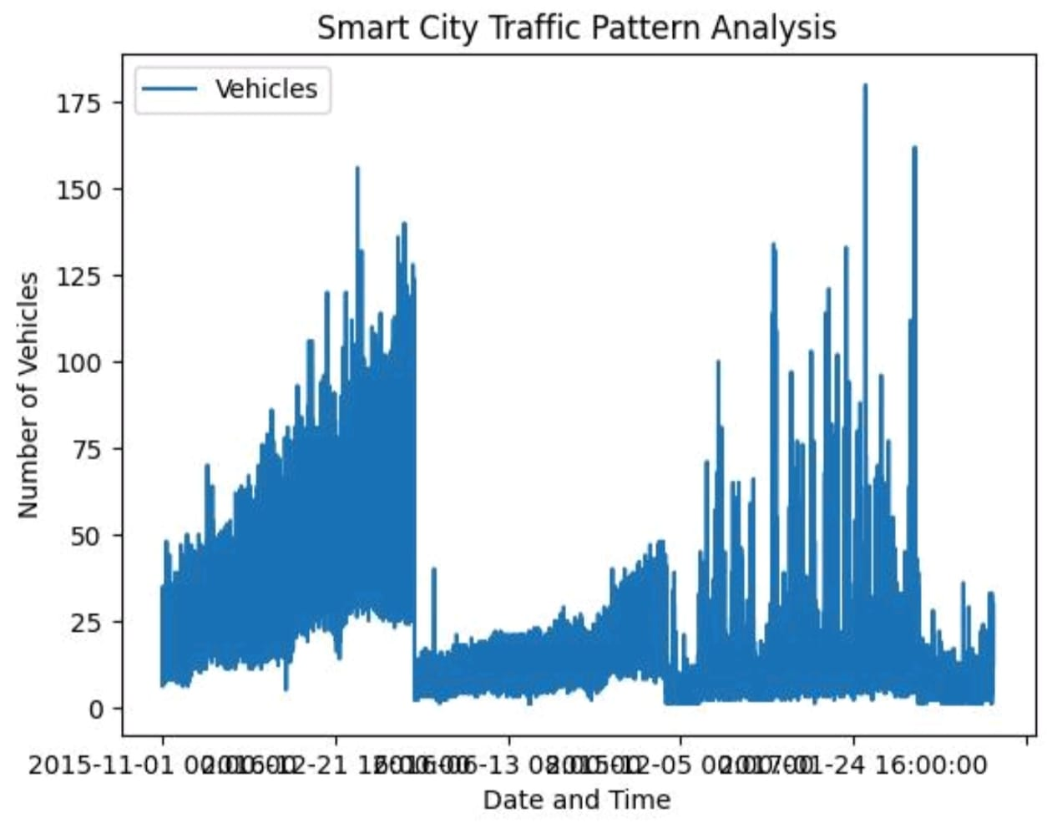
"The graph shows that Junction 1 has the highest traffic, while Junction 4 has the lowest traffic."

Performance Test

Performance testing was conducte d to evaluate the efficiency and accuracy of the Forecasting of Smart City Traffic Patterns project. The system was tested using the traffic dataset in Google Colab. The objective of the testing process was to verify that the dataset could be imported successfully, preprocessed correctly, analyzed efficiently, and visualized without errors. Various test cases were performed to ensure that data cleaning, feature extraction, traffic pattern analysis, and visualization worked as expected. The results confirmed that the system processed the traffic data accurately, generated meaningful graphs and insights, and successfully identified traffic trends across different time periods. The overall performance met the project objectives by providing reliable traffic analysis and forecasting results.

Test Plan/ Test Cases
The project was tested using the smart city traffic dataset. The main objective was to verify whether the dataset could be successfully imported, cleaned, analyzed, and visualized. The following test cases were considered:
Verify successful dataset import into Google Colab.
Check whether missing values are handled correctly.
Verify successful data preprocessing and analysis using Pandas.
Ensure bar charts, line graphs, and other visualizations are generated without errors.
Validate that the final output provides meaningful insights into traffic patterns and forecasting.

Test Procedure
The traffic dataset was uploaded into Google Colab and processed using Python. Initially, the dataset was cleaned by handling missing values and checking data quality. After preprocessing, the data was analyzed using the Pandas library. Visualization techniques such as bar charts and line graphs were created using Matplotlib. Finally, the outputs were verified to ensure that the analysis was accurate and that the graphs correctly represented traffic flow and traffic pattern trends.

Performance Outcome
The project successfully completed all the planned test cases. The dataset was processed without major errors, and the generated visualizations clearly represented traffic patterns and congestion trends. The final output was accurate, easy to understand, and met the objectives of the project. Overall, the system performed efficiently and provided meaningful insights for forecasting smart city traffic patterns.

My learnings

This internship helped me improve my programming skills in Python and strengthened my understanding of data analysis and traffic forecasting concepts. I learned how to clean traffic datasets, preprocess data, analyze traffic patterns using Pandas, and create visualizations using Matplotlib. I also gained experience in data preprocessing, traffic pattern analysis, project documentation, problem-solving, and presenting technical work professionally. This internship increased my confidence and prepared me for future opportunities in Data Science, Machine Learning, and Artificial Intelligence.

Future work scope

This project can be further enhanced by integrating advanced Machine Learning and Deep Learning algorithms to improve traffic prediction accuracy. Larger and real-time traffic datasets can be used for better analysis and forecasting. Interactive dashboards can be developed using modern visualization tools to monitor live traffic conditions. Future improvements may also include weather data integration, accident prediction, GPS-based traffic monitoring, and real-time traffic management systems to support smart city planning and decision-making.

